WIKI-AM,C-Taino-Mask with anthropomorphic face with Cohoba Bowl

WIKI Catalogue Number: F1619.2.T3.M no.

# Culture: Taino

# Source Location: Dominican Republic

Date: 13th–15th century

Description: Mask with anthropomorphic face with Cohoba Bowl

Medium: manatee bone

Dimensions: H 3 3/8 in. x W x D in. (H x W x D cm.)

Weight: lb. oz. (kg. gm.)

Classification: Sculpture

References:

Fatima Bercht; Ricardo E Alegría. 1998. *Taino: Pre-Colombian Art and Culture from the Caribbean*. Museo del Barrio: New York, NY, p.

Roberts, Larry; Josh Roberts; Richard Rossetto. [2014] *Taíno sculpture: art of the gods*. Micanopy, FL : Signature Book Printing, p.

### 

### 

### Delivery package 1 of 1

Estimated delivery Monday, Mar 14, 2016 - Monday, Mar 21, 2016

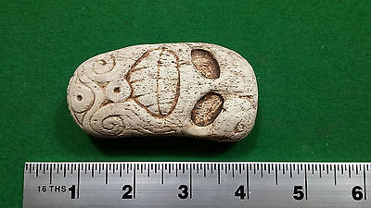

#### [Taino carving with Small personal Cohoba Bowl - Pre Columbian](http://www.ebay.com/itm/272153336390)

|  |  |
| --- | --- |
| Item price | $99.00 |
| Quantity | 1 |
| Item number | 272153336390 |
| Shipping service | Standard Int'l Shipping |